**LAB MANUAL : WEB PROGRAMMING LANGUAGES(WPL).**

Q1: Make a program shows the sum of digits

SOURCE CODE:

1. <?php
2. $num = 14597;
3. $sum=0; $rem=0;
4. **for** ($i =0; $i<=strlen($num);$i++)
5. {
6. $rem=$num%10;
7. $sum = $sum + $rem;
8. $num=$num/10;
9. }
10. echo "Sum of digits 14597 is $sum";
11. ?>

OUTPUT:

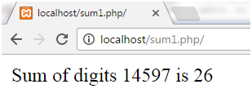

Q2: Make a program to show odd or even numbers.

SOURCE CODE:

1. <?php
2. $number=1233456;
3. **if**($number%2==0)
4. {
5. echo "$number is Even Number";
6. }
7. **else**
8. {
9. echo "$number is Odd Number";
10. }
11. ?>

OUTPUT:

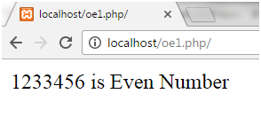

Q3: Make a program to list the first 15 prime numbers.

SOURCE CODE:

1. <?php
2. $count = 0;
3. $num = 2;
4. **while** ($count < 15 )
5. {
6. $div_count=0;
7. **for** ( $i=1; $i<=$num; $i++)
8. {
9. **if** (($num%$i)==0)
10. {
11. $div_count++;
12. }
13. }
14. **if** ($div_count<3)
15. {
16. echo $num." , ";
17. $count=$count+1;
18. }
19. $num=$num+1;
20. }
21. ?>

OUTPUT:

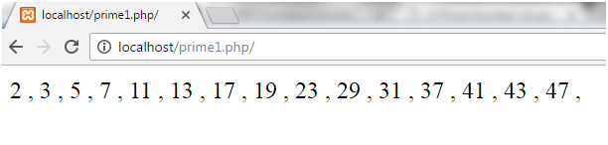

Q4: Make a program to print the table

SOURCE CODE:

1. <?php
2. define('a', 7);
3. **for**($i=1; $i<=10; $i++)
4. {
5. echo $i*a;
6. echo '<br>';
7. }
8. ?>

OUTPUT:

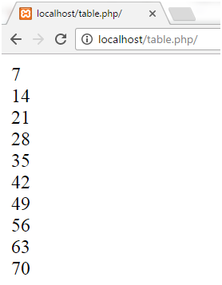

Q5: Make a program for factorial.

SOURCE CODE:

1. <?php
2. $num = 4;
3. $factorial = 1;
4. **for** ($x=$num; $x>=1; $x--)
5. {
6. $factorial = $factorial * $x;
7. }
8. echo "Factorial of $num is $factorial";
9. ?>

OUTPUT:

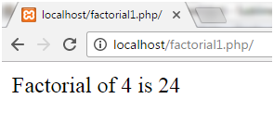

Q6: Make a program checks whether 407 is Armstrong or not.

SOURCE CODE:

1. <?php
2. $num=407;
3. $total=0;
4. $x=$num;
5. **while**($x!=0)
6. {
7. $rem=$x%10;
8. $total=$total+$rem*$rem*$rem;
9. $x=$x/10;
10. }
11. **if**($num==$total)
12. {
13. echo "Yes it is an Armstrong number";
14. }
15. **else**
16. {
17. echo "No it is not an armstrong number";
18. }
19. ?>

OUTPUT:

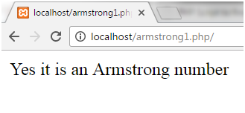

Q7: Make a program to check palindrome number.

SOURCE CODE:

1. <?php
2. **function** palindrome($n){
3. $number = $n;
4. $sum = 0;
5. **while**(floor($number)) {
6. $rem = $number % 10;
7. $sum = $sum * 10 + $rem;
8. $number = $number/10;
9. }
10. **return** $sum;
11. }
12. $input = 1235321;
13. $num = palindrome($input);
14. **if**($input==$num){
15. echo "$input is a Palindrome number";
16. } **else** {
17. echo "$input is not a Palindrome";
18. }
19. ?>

OUTPUT:

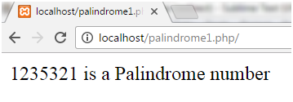

Q8: Make a program to print Fibonacci series.

SOURCE CODE:

1. <?php
2. $num = 0;
3. $n1 = 0;
4. $n2 = 1;
5. echo "<h3>Fibonacci series for first 12 numbers: </h3>";
6. echo "\n";
7. echo $n1.' '.$n2.' ';
8. **while** ($num < 10 )
9. {
10. $n3 = $n2 + $n1;
11. echo $n3.' ';
12. $n1 = $n2;
13. $n2 = $n3;
14. $num = $num + 1;
15. ?>

OUTPUT:

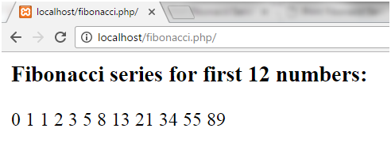

Q9: Make a program to print reverse number.

SOURCE CODE:

1. <?php
2. $num = 23456;
3. $revnum = 0;
4. **while** ($num > 1)
5. {
6. $rem = $num % 10;
7. $revnum = ($revnum * 10) + $rem;
8. $num = ($num / 10);
9. }
10. echo "Reverse number of 23456 is: $revnum";
11. ?>

OUTPUT:

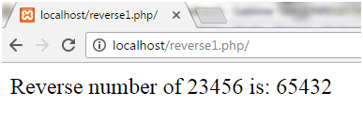

Q10: Make a program to reverse string program using strrev() function

SOURCE CODE:

1. ?php
2. $string = "JAVATPOINT";
3. echo "Reverse string of $string is " .strrev ( $string );
4. ?>

OUTPUT:

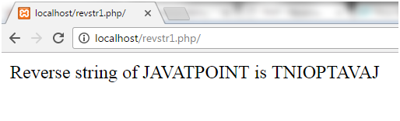

Q11: Make a program to swapping two numbers.

SOURCE CODE:

1. <?php
2. $a = 45;
3. $b = 78;
4. // Swapping Logic
5. $third = $a;
6. $a = $b;
7. $b = $third;
8. echo "After swapping:<br><br>";
9. echo "a =".$a."  b=".$b;
10. ?>

OUTPUT:

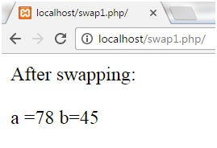

Q12: Make a program to print add two numbers

SOURCE CODE:

1. <?php
2. $x=15;
3. $y=30;
4. $z=$x+$y;
5. echo "Sum: ",$z;
6. ?>

OUTPUT:

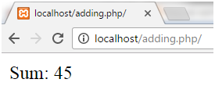

Q13: Make a program to print subtracting two numbers.

SOURCE CODE:

1. <?php
2. $x=30;
3. $y=15;
4. $z=$x-$y;
5. echo "Difference: ",$z;
6. ?>

OUTPUT:

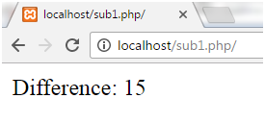

Q14: Make a program to print area of triangle.

SOURCE CODE:

1. <?php
2. $base = 10;
3. $height = 15;
4. echo "area with base $base and height $height= " . ($base * $height) / 2;
5. ?>

OUTPUT:

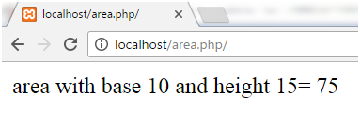

Q15: Make a program to print area of rectangle.

SOURCE CODE:

1. <?php
2. $length = 14;
3. $width = 12;
4. echo "area of rectangle is $length * $width= " . ($length * $width) . "<br />";
5. ?>

OUTPUT:

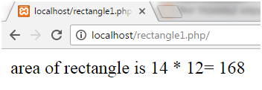

Q16: Make a program to print leap year.

SOURCE CODE:

1. <?php
2. **function** isLeap($year)
3. {
4. **return** (date('L', mktime(0, 0, 0, 1, 1, $year))==1);
5. }
6. //For testing
7. **for**($year=1991; $year<2016; $year++)
8. {
9. If (isLeap($year))
10. {
11. echo "$year : LEAP YEAR<br />\n";
12. }
13. **else**
14. {
15. echo "$year : Not leap year<br />\n";
16. }
17. }
18. ?>

OUTPUT:

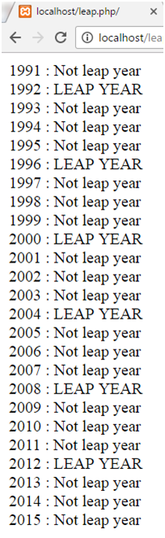

Q17: Make a program to print alphabet triangle method.

SOURCE CODE:

1. <?php
2. $alpha = range('A', 'Z');
3. **for**($i=0; $i<5; $i++){
4. **for**($j=5; $j>$i; $j--){
5. echo $alpha[$i];
6. }
7. echo "<br>";
8. }
9. ?>

OUTPUT:

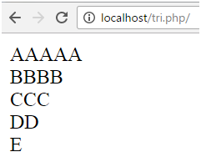

Q18: Make a program to print alphabet pattern.

SOURCE CODE:

1. <?php
2. $alpha = range('A', 'Z');
3. **for** ($i=5; $i>=1; $i--) {
4. **for**($j=0; $j<=$i; $j++) {
5. echo ' ';
6. }
7. $j--;
8. **for** ($k=0; $k<=(5-$j); $k++) {
9. echo $alpha[$k];
10. }
11. echo "<br>\n";
12. }
13. ?

OUTPUT:

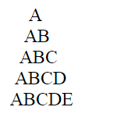

Q19: Make a program to print number pattern.

SOURCE CODE:

1. <?php
2. $k=1;
3. **for**($i=0;$i<4;$i++){
4. **for**($j=0;$j<=$i;$j++){
5. echo $k." ";
6. $k++;
7. }
8. echo "<br>";
9. }
10. ?>

OUTPUT:

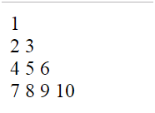

Q20: Make a program to print star triangle.

SOURCE CODE:

1. <?php
2. **for**($i=0;$i<=5;$i++){
3. **for**($k=5;$k>=$i;$k--){
4. echo "  ";
5. }
6. **for**($j=1;$j<=$i;$j++){
7. echo "*  ";
8. }
9. echo "<br>";
10. }
11. **for**($i=4;$i>=1;$i--){
12. **for**($k=5;$k>=$i;$k--){
13. echo "  ";
14. }
15. **for**($j=1;$j<=$i;$j++){
16. echo "*  ";
17. }
18. echo "<br>";
19. }
20. ?>

OUTPUT:

